Honeymoon
Include
- 3 Nights accommodation at hotel choice incl. Breakfast
- Tour Guide (Indonesian/English s.g)
- Tour Guide (Indonesian/English s.g)
- AC transport
- 1 x Candle Light Dinner, 2 x Lunch at local restaurant
- Donation, entrance fee, mineral water
- Charter boat to Gili Nanggu
- Transfer Airport – Hotel - Airport
Valid for: Domestic & Kim’s holder market.

ucts here.

• List your services or products here.

• List your services or products here.

• List your services or products here.

• List your services or products here.

• List your services or products here.

• List your services or products here.

• List your services or products here.

4 Days 3 Nights

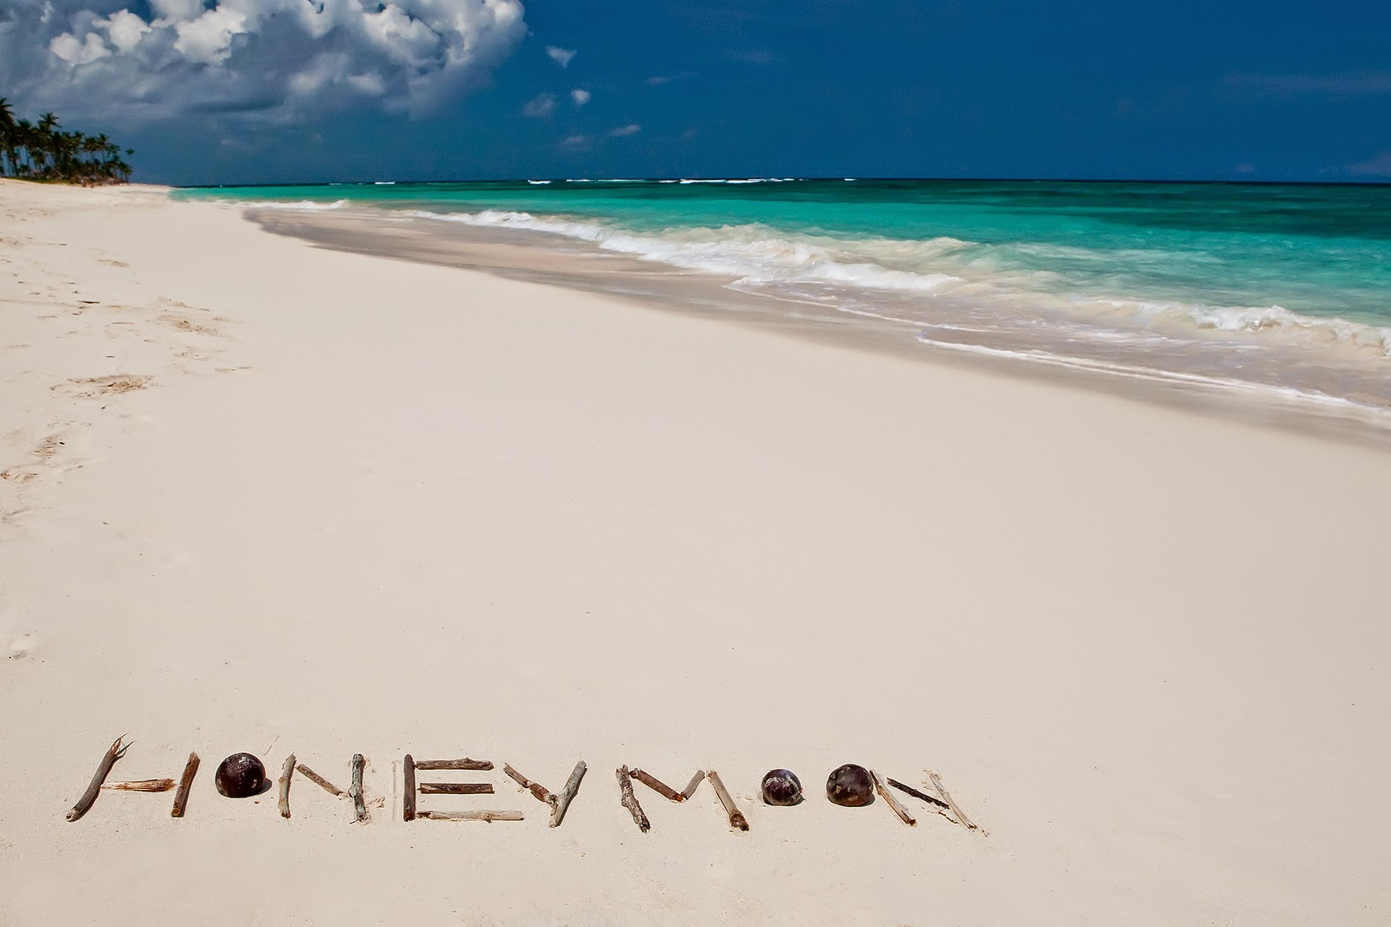

Day 01
Arrive at Airport Lombok, meeting service.
Transfer in to Hotel
Romantic Candle Light Dinner at Hotel

Day 02

Gili Nanggu Virgin IslandTour
After breakfast start for full Day tour direct drive to Lembar harbor or Tawun village than cross by outrigger boat to Gili Nangu a virgin small island is a natural conversation with superbly white sand beach all of which provided excellent beach for swimming, snorkeling and sunbathing. Lunch at local restaurant. Late afternoon will be return to hotel.

Day 03
Full Day Sasak tour
Discover they way of sasak tribe doing daily works for living, visiting: Banyumulek pottery village, Sukarara, hand weaving village, Sade, or Rambitan, village sasak village with traditional houses. Drive to Kuta, and Tanjung Aan Beach with white sand beach. Lunch will be at local restaurant.

Day 04
Free program untill transfer to Airport to next destination

Special Rate

Hotel | Rate /Couple | HSS/Couple  Applied on HSS period
Holiday Resort (*4) | 7,300,000 | 1.000,000
Jayakarta (*4) | 6,765,000 | 650,000
Katamaran ( *4 ) | 9,800,000 | 1,600,000

High Season Period
08 – 23 /06/2019; 01 – 31/08/2019→(Holiday Resort).
08 – 23 /06/2019 →(Jayakarta)
08/06/2018 – 15/09/2019→(Katamaran)

